**RBIs Don’t Reflect Player Ability**

RBI is still one of the most used stats to discuss the quality of season a player had. Many think it is a useful stat. I claim it is meaningless. Here is how you can decide which side of this debate you stand. Which player had the better season?

* Player A: .300 BA, .420 OBP, .550 SLG, 120 RBI
* Player B: .301 BA, .421 OBP, .551 SLG, 100 RBI

To me, Player B had the better season. I truly think that, after controlling for batting average, on base percentage, and slugging percentage, runs batted in is only indicative of how often your teammates get on base. Are you a better player because your leadoff guy gets on more? No. Player B had the better season because, though the difference is small, he had a better slash line.

**An Anecdote**

Here is an example of what I claim. The 2013 Reds leadoff hitter was Shin-Soo Choo and Joey Votto hit third. These two players were number two and number four in all of baseball in on base percentage, each reaching base over 42% of the time. In 2013, Brandon Phillips who hit fifth had his career best in RBI. However, 2013 was far from Phillips’ best season. In fact, if you rank his seasons by batting average, 2013 was his **thirteenth** best. Jay Bruce who hit fourth most of that year also set a career best in RBI.

Bruce and Phillips led the team in RBI that year but Choo and Votto were the actual important part of that team. This is just a simple example to warm you up for the topic of today’s article. RBI as a stat is completely useless. RBI is not representative of a player’s offensive value but rather is representative of how often other players were on base when they came up to bat.

**The Method**

Remember that we can use the technique described in our previous article (hyperlink) to simulate entire baseball seasons. For consistency, we will again do our simulations using the opening day roster of the 2016 Chicago Cubs. Our goal is to show that the RBI’s of a particular player can vary wildly depending only on their spot in the batting order.

So, we will consider the Cubs’ player who had arguably the best season in 2016, Kris Bryant. Kris Bryant had 102 RBI’s on the season. However, Bryant spent most of his season batting 2nd or 3rd in the lineup. First we’ll show that these spots in the order are *not* optimal for generating RBI’s. We will simulate hundreds of full seasons where Kris Bryant bats out of each spot in the lineup and show his RBI numbers drastically changing.

**The Results**

We simulated the number of RBI’s that Kris Bryant would get when hitting from each spot in the Cubs 2016 lineup. Here is what we found:

|  |  |
| --- | --- |
| Lineup Spot | Average Projected RBIs |
| 1 | 106 |
| 2 | 119 |
| 3 | 127 |
| 4 | 134 |
| 5 | 141 |
| 6 | 131 |
| 7 | 119 |
| 8 | 115 |
| 9 | 107 |

And, pictorially, the point I am trying to make is even clearer.

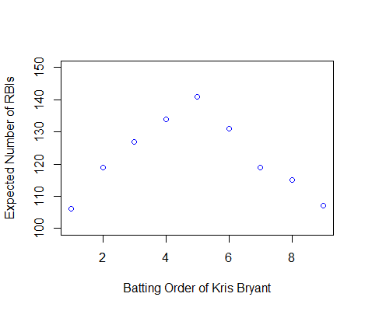

Note: These numbers have overestimated the actual RBIs of Kris Bryant. We realized that our method was overestimating at-bats for two reasons. First, we are not including double play statistics which means we are letting players remain on base more often than they should. Second, Kris Bryant only played in about 155/162 games this year. If we normalize for RBI’s/at-bat and use the fact that Bryant spent about half the season batting 2nd and half the season batting 3rd, we would actually predict Bryant having about 112 RBIs which is within an acceptable deviation of his actual 102 RBIs.

What do these numbers say? They tell us that a player’s RBIs are heavily dependent on where they bat in the order. There is over a 30% increase in RBIs from the optimal spot in the lineup to the worst spot in the lineup. Any other stat that could be changed by 30% would be immediately discarded as ‘too easy to manipulate’.

**The Alternative**

What do people *want* RBI to say? Looking back at Player A and Player B from the beginning of this article, your buddy might say Player A is way better because ‘he gets his guys home’. He might also say ‘Player A is good when it counts’. What he is trying to say is that he is good under pressure.

We already have a stat that does that in a much-less roundabout way. I don’t know if I believe in different players having different affinities for getting hits when there is more or less stress put on them. What I mean is, I haven’t looked at the data. But, if you want to say Player A is better than Player B because he hits well under pressure, just talk about his batting average **with runners in scoring position**. Or, use similar metrics like ‘batting average in the last 2 innings of one run games with 2 outs’.